Towamencin Family Chiropractic NEW PATIENT APPLICATION
Welcome to our Practice! Please thoroughly complete all questions.
All information is vital to your care in our office. Thank you.

Name:___________________________________ Today’s Date:____________________

Address:__________________________________________________________________

City/State/Zip:________________________________ E-Mail:___________________

Phone: Home _________________ Work ________________ Cell _________________

Marital Status: Married/Widowed/Divorced/Single

Birthdate:_____/_____/_____ Age:______ SS#:___________________

Who may we thank for referring you? ______________________________________

Your Prior Doctor of Chiropractic:________________________________________

Last time you went to previous Doctor of Chiropractic:____________________

General Practitioner:__________________ City ___________ Phone: _________

Your Employer:______________________________ Phone Number:________________

Employer’s Address:_______________________________________________________

Occupation:_______________________________________________________________

Spouse’s Name:_____________________Spouse’s Employer: ____________________

Children’s Names & Ages:__________________________________________________

Favorite Hobbies or Interests:_____________________________________________________
Circle areas of Health Concerns
Health Concerns for Consulting Our Office:
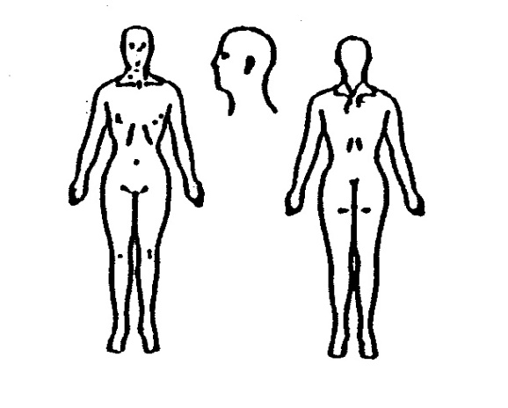
1.________________________ 3.________________________

2.________________________ 4.________________________

Rate your pain level from 0-10. 0 = No Pain 10= Extreme Pain
1.__________________________ 3.____________________________

2.__________________________ 4.___________________________

Have you had same or similar problem(s) before? ___Yes ___No
How Long?: _____________________Please Explain: __________________________

Father/Mother/Brother/Sister/Children, with similar problems?

Other Doctors who have treated this problem:______________________________

__________________________________________________________________________

Surgeries you have had:___________________________________________________

Medication(s) you currently take and for what purpose: ___________________
__________________________________________________________________________

Have you ever been diagnosed with cancer?___ If so, what kind?
__________________________________________________________________________

Do you smoke now?_____ Past?_____ How Long?_____ Packs per day?___________

How do you sleep? Stomach____ Side____ Back____

What have you heard about chiropractic?
__________________________________________________________________________

Do you know what a subluxation is? If yes, please describe:_________________________________________________________________

What daily rituals for spinal health do you presently practice?
__________________________________________________________________________

Do you have health insurance?______ Name of company:______________________

Method of Payment for First Visit: _____Cash _____Check _____Credit Card

Is this the result of an auto or work injury? Yes _____ No ______
If so, when? ________________________________________________________
If this is a work injury, is there a panel chiropractor that your company’s Workmen’s Compensation Insurance requires you to see in the first 90 days? If so, please list their name.
__________________________________________________________________________
Is there any chance you are pregnant? Yes___ *No___ Nursing? Yes___ No____
*Pregnancy Release: This is to certify that to the best of my knowledge I am not pregnant and the doctor has my permission to perform an x-ray evaluation. I have been advised that x-rays can be dangerous to an unborn child.
Signature (Female Patients Only): ______________________________________________ Date: __________

I understand and agree that health and accident insurance policies are an arrangement between me and my insurance company and that all services rendered me are charged directly to me and that I am personally responsible for payment. I also understand that if I suspend or terminate my care and treatment, any fees for professional services rendered me will be immediately due and payable. I hereby authorize the Doctor to examine and treat my conditions as he deems appropriate through the use of Chiropractic health care, and I give authority for these procedures to be performed. It is understood and agreed the amount paid the Doctor for X-rays is for examination only and the X-ray negatives will remain the property of this office. The Doctor will not be held responsible for any pre-existing medically diagnosed conditions, nor for any medical diagnosis. I hereby authorize the use or disclosure of my individually identifiable health information as described below. I understand this authorization is voluntary. I understand that if the organization authorized to receive the information is not a health plan or health care provider, the released information may no longer be protected by federal privacy regulations, and that it may be re-disclosed by the recipient. The above information is true and accurate to the best of my knowledge. My reason for consultation with the Doctor is for evaluation of my physical health and the potential for improvement.
Patient Signature: __________________________________________________________Date:___________________________ Revised 1/2011

